Additional file 1
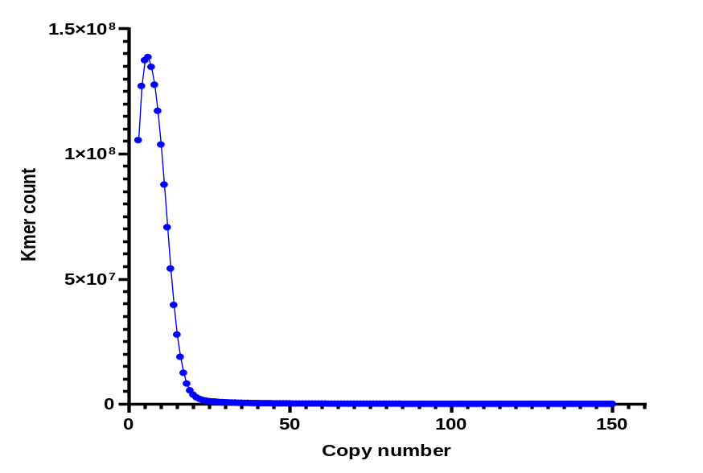
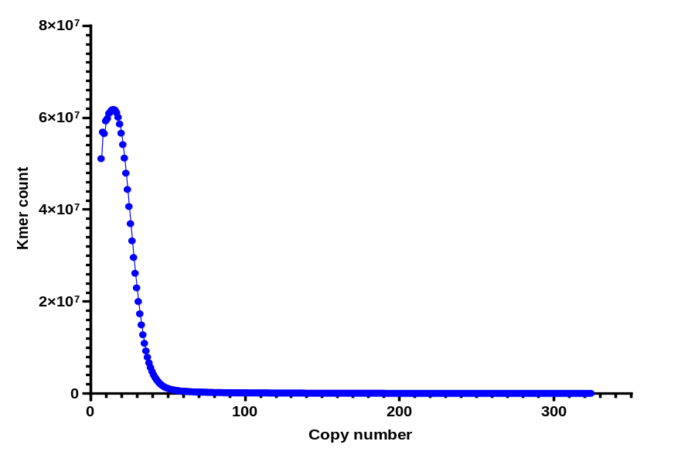
a
b
Additional file 1. a). K-mer spectrum for the genome sequence of a male B. duperreyi. The Illumina run yielded 96.707502Gb of clean data, which generated 14310783435 K-mer sequences. The solid blue line shows the k-mer spectrum above 1000 k-mer count. b). K-mer spectrum for the genome sequence of a female B. duperreyi. The Illumina run yielded 81.411468Gb of clean data, which generated 36695139446 k-mer sequences. The solid blue lines show the k-mer spectrum above 1000 k-mer count (K-mer count against k-mer copy number).

